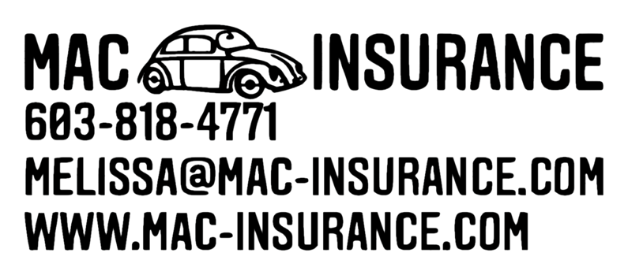

Report a Claim – Phone Directory

Allstate
800-255-7828
American Modern
800-375-2075
Arrowhead (Zurich Garage Insurance)
877-777-6440
Bristol West Auto
800-274-7865
Colonial Surety
800-221-3662
Coterie (Benchmark Insurance)
855-680-2440
Employers
855-365-6010
Foremost Specialty
800-527-3907
Hagerty
800-922-4050
Hanover
800-628-0250
Hippo
855-999-9746
Hiscox
866-424-8508
Liberty Mutual (Business Insurance)
844-325-2467
Memic
800-636-4292
Merchants
800-952-5246
Metlife/Farmers/Foremost Signature
800-854-6011
NatGen Premier
844-287-2236
Next Insurance
855-222-5919
Openly
857-990-9080
PIE Insurance
844-581-0828
Progressive
800-274-4499
Safeco
800-332-3226
Safety
800-951-2100
TokioMarine/HCC
888-637-0872
Travelers
877-425-2466
USLI
888-523-5545

